Crowle Neighbourhood Plan 2024-2041
Strategic Environmental Assessment (SEA) and Habitats Regulations Assessment (HRA) Screening Opinion

September 2024



CONTENTS

1. | Introduction
1.1 | Background
1.2 | Draft Crowle Neighbourhood Plan Summary
1.3 | Crowle Designated Area Map
1.4 | Draft Crowle Neighbourhood Plan Policy Summaries
1.5 | Strategic Environmental Assessment (SEA)
1.6 | Habitats Regulations Assessment (HRA)
2. | SEA Screening
2.1 | SEA Screening Assessment
2.2 | SEA Screening Opinion
3. | HRA Screening
3.1 | HRA Screening Assessment
3.2 | HRA Screening Opinion
4. | Conclusions  Appendix: Statutory Environmental Bodies Consultation Responses

1. INTRODUCTION
1.1 BACKGROUND
This screening report is designed to determine whether the content of the draft Crowle Neighbourhood Plan (CNP) requires a Strategic Environmental Assessment (SEA) in accordance with the European Directive 2001/42/EC and associated Environmental Assessment of Plans and Programmes Regulations 2004.
Whether a Neighbourhood Development Plan requires a SEA, and if so the level of detail needed, will depend on what is proposed in the draft Neighbourhood Development Plan. The National Planning Practice Guidance (NPPG) states that a SEA may be required, for example, where:
- the Neighbourhood Development Plan allocates sites for development;
- the Neighbourhood Development Plan Area contains sensitive natural or heritage assets that may be affected by the proposals in the plan;
- the Neighbourhood Development Plan may have significant environmental effects that have not already been considered and dealt with through the SEA of the Local Plan in the area.
The screening report also examines the potential impact of the draft Crowle Neighbourhood Plan on internationally designated wildlife sites and determines if the plan requires a Habitats Regulations Assessment (HRA).
When deciding on whether the proposals are likely to have significant effects, the local authority is required to consult Historic England, Natural England and the Environment Agency. Where the local planning authority determines that the plan is unlikely to have significant environmental effects (and, accordingly, does not require an environmental assessment) it should prepare a statement of its reasons for the determination.
1.2 DRAFT CROWLE NEIGHBOURHOOD PLAN SUMMARY
The draft Crowle Neighbourhood Plan is essentially a community-led framework for guiding future development and growth of the parish. The Neighbourhood Area was designated on 12 November 2022 by Wychavon District Council. This is the first neighbourhood plan Crowle Parish Council have prepared and once ‘made’ it will cover the period from 2024 to 2041. Thirteen draft policies have been proposed, focusing on topics including Housing, Sustainable Development, Community Facilities, Historic and Natural Environment, Key Views, Local Green Spaces / Local Gap, and Design in the Built Environment.
1.3 CROWLE DESIGNATED NEIGHBOURHOOD AREA
Figure 1 – Designated Crowle Neighbourhood Area

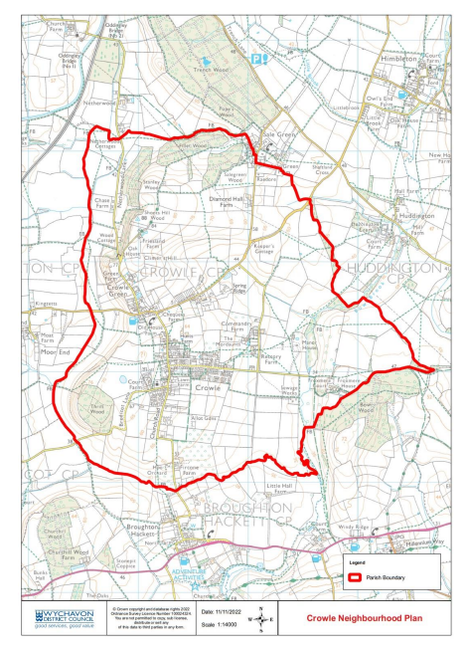

1.4 DRAFT CROWLE NEIGHBOURHOOD PLAN POLICY SUMMARIES
13 policies are proposed in the draft Crowle Neighbourhood Plan (CNP); they are summarised below.
DRAFT POLICY | SUMMARY
CRW1: Design | Policy CRW1 requires development proposals to maintain and enhance the local distinctiveness of the neighbourhood area and achieve a high quality of design via five criteria. Modern design is also supported where innovative, make a positive contribution to the area and incorporate renewable and sustainable build. The CNP also includes design guidance and codes to support these policy requirements.
CRW2: Crowle Conservation Area | Policy CRW2 within the Crowle Conservation Area or its setting, development proposals are required to preserve or enhance its character or appearance, as well as have regard to the significance and special interest of the Conservation Area.
CRW3: Landscape Character | Policy CRW3 development proposals are required to show how they have implemented the Landscape Character Assessments, reinsforce existing landscape features and respect the setting of Crowle and other settlements within the Neighbourhood Area.
CRW4: Crowle/Crowle Green Local Gap | Policy CRW4 identifies a local gap between Crowle and Crowle Green to maintain the openness and retain the setting of these two distinct built-up areas of the village.
CRW5: Key views | Policy CRW5 identifies 16 key views as set out in Plan 4 in the CNP. Development proposals that have a impact on the key views are required to provide supporting evidence to how the proposals have considered these and how the design, setting and landscape etc. have taken them into consideration.
CRW6: Local Green Spaces | Policy CRW6 identifies 4 Local Green Spaces and sets these out in Plan 5 of the CNP.
CRW7: Neighbourhood Area housing | Policy CRW7 seeks to establish that housing requirement set out by the draft SWDPR (Annexe E) is met through a combination of local plan allocations, existing commitments and the granting of future planning permissions.
CRW8: Housing development | PolicyCRW8 for development proposals to be supported they are required to meet eight criteria. These cover design, infrastructure, parking, sustainable build and renewable energy features, sustainable transport and amenity.
CRW9 Housing mix | Policy CRW9 sets out a requirement that development proposals need to show how they have reflected the house types and size from any housing need assessment, identifies specific types of dwelling and supports self-build housing.
CRW10 Householder development | Policy CRW10 householder development proposals need to accord with CRW7 as well as all three criteria relating to scale, massing and height and loss of amenity/parking space.
CRW11 Small-scale employment | Policy CRW11 small scale employment proposals will be supported provided they satisfy the four identified criteria.
CRW12 Community facilities | Policy CRW12 seeks to safeguard seven identified community assets (shown at Plan 6 in the CNP) and sets out four criteria that new or the enhance of existing community facilities are required to meet.
CRW13 Renewable and low carbon energy | Policy CRW 13 supports renewable and low carbon energy proposals that benefit the local community and meet the three criteria identified.

1.5 STRATEGIC ENVIRONMENTAL ASSESSMENT (SEA) PROCESS
The basis for Strategic Environmental Assessment (SEA) legislation is European Directive 2001/42/EC which was transposed into English law by the Environmental Assessment of Plans and Programmes Regulations 2004, or SEA Regulations. Detailed guidance on these Regulations can be found in the Government publication ‘A Practical Guide to the Strategic Environmental Assessment Directive’ (OPDM 2005).
The SEA process aims to ensure that likely significant environmental effects arising from a Plan are identified, assessed, mitigated, communicated and monitored, and that opportunities for public involvement are provided. It enables environmental considerations to be accounted for in decision-making throughout the production of a Plan in an integrated manner.
Figure 2 sets out the screening procedure and how a plan should be assessed against the SEA Directive criteria. This outline procedure has then been applied to the draft Crowle Neighbourhood Plan in Table 1.
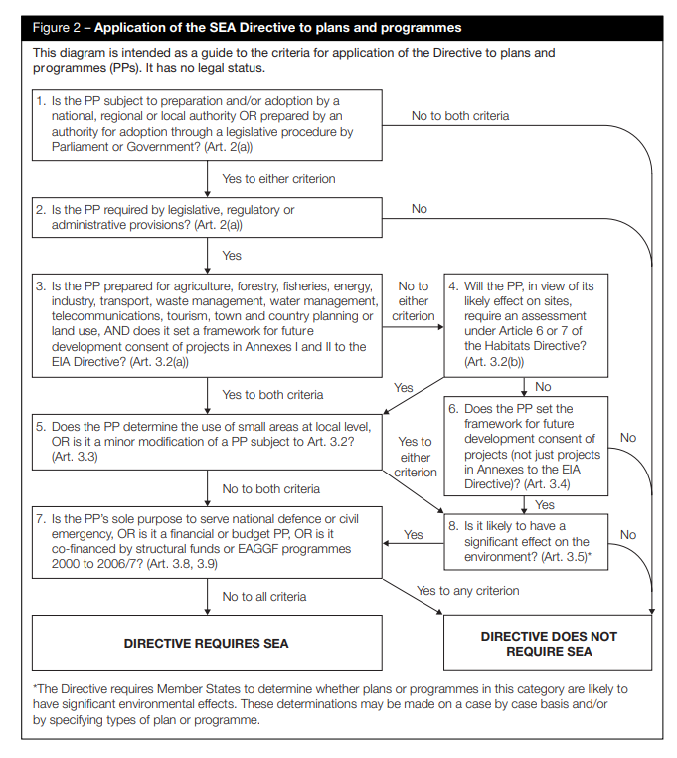
Figure 2 Application of the SEA Directive to Plans and Programmes (source: A Practical Guide to Strategic Environmental Assessment Directive, ODPM, 2005)
Table 1: Assessment of the draft Crowle Neighbourhood Plan using SEA Directive Criteria
Stage | Y/N | Reason
1. Is the Crowle Neighbourhood Plan subject to preparation and/or adoption by a national, regional or local authority OR prepared by an authority for adoption through a legislative procedure by Parliament or Government? (Art. 2(a)) | Y | The Neighbourhood Plan is being prepared by a Qualifying Body, i.e. Crowle Parish Council under the Localism Act 2011. If the Plan is passed by means of an either Examination and/or Referendum, it will be formally adopted/made by the Local Planning Authority. It will then form part of the local development framework and be afforded significant weight in planning decisions.
2. Is the Crowle Neighbourhood Plan required by legislative, regulatory, or administrative provisions? (Art. 2(a)) | N | The preparation of a Neighbourhood Plans is not a mandatory requirement, and the Crowle Neighbourhood Plan is being prepared voluntarily by the local Qualifying Body in line with the provisions of the Localism Act. The Plan is being prepared to steer development and set out policies for decision taking that reflect the community views and the Vision and Objectives set out in the CNP. If the Plan is adopted it will form part of the statutory development plan, and it is therefore considered necessary to answer the following questions to determine if an SEA is required.
3. Is the Crowle Neighbourhood Plan prepared for agriculture, forestry, fisheries, energy, industry, transport, waste management, water management, telecommunications, tourism, town and country planning or land use, AND does it set a framework for future development consent of projects in Annexes I and II to the EIA Directive? (Art 3.2(a)) | Y | The Plan is prepared for the purposes of town and country planning and sets out a framework for future development consent of projects.
4. Will the Crowle Neighbourhood Plan, in view of its likely effect on sites, require an assessment for future development under Article 6 or 7 of the Habitats Directive? (Art. 3.2 (b)) | N | See Screening Opinion for HRA in Section 3 of this report.
5. Does the Crowle Neighbourhood Plan determine the use of small areas at local level, OR is it a minor modification of a PP subject to Art. 3.2? (Art. 3.3) | Y | The Crowle Neighbourhood Plan is made up of several policies which, when adopted, will form part of the Local Development Framework, and so will have significant weight in planning decisions.
6. Does the Crowle Neighbourhood Plan set the framework for future development consent of projects (not just projects in annexes to the EIA Directive)? (Art 3.4) | Y | When readopted, the Crowle Neighbourhood Plan will be a statutory planning document. It will form part of the Local Development Framework and so will have significant weight in planning decisions. The responsibility for issuing development consent will remain with the Local Authority.
7. Is the Crowle Neighbourhood Plan sole purpose to serve the national defence or civil emergency, OR is it a financial or budget PP, OR is it co-financed by structural funds or EAGGF programmes 2000 to 2006/7? (Art 3.8, 3.9) | N | Not Applicable
8. Is it likely to have a significant effect on the environment? (Art. 3.5) | ? | The Crowle Neighbourhood Plan is not proposing any further allocated sites for development. However, it does set out policies for the purposes of Development Management that may have a significant effect on the environment. To investigate the likelihood of potential impacts further a case-by-case assessment has been conducted, the full results of which can be found in Table 2.

Based upon the initial screening carried out against the criteria in Table 1 above, the draft Crowle Neighbourhood Plan may have a significant effect on the environment. To explore these potential effects further, a case-by-case assessment has been conducted. The criteria used in the undertaking of such an assessment are drawn from Article 3.5 (Annex II) of the SEA directive, and the results are shown in Table 2.
1.6 HABITATS REGULATIONS ASSESSMENT (HRA) PROCESS
The Habitats Regulations Assessment (HRA) refers to the assessment required for any plan or project to assess the potential implications for European wildlife sites. The HRA therefore looks at whether the implementation of the plan or project would harm the habitats or species for which European wildlife sites are designated. The relevant European wildlife site designations are Special Protection Areas (SPAs) and Special Areas of Conservation (SACs), which together form part of the Natura 2000 network.
In addition to SPAs and SACs, Ramsar sites are also designated areas which, as a matter of government policy, are to be treated in the same way as European wildlife sites (although they are not covered by the Habitats Regulations). European wildlife sites and Ramsar sites are collectively known as internationally designated wildlife sites.
The legislation sets out a process to assess the potential implications of a plan on internationally designated wildlife sites. The first stage of this process is a screening exercise where the details of nearby internationally designated sites are assessed to see if there is the potential for the implementation of the plan to have an impact.

2. SEA SCREENING
2.1 SEA SCREENING ASSESSMENT
European Directive 2001/42/EC requires a full Strategic Environmental Assessment to be undertaken for certain types of plans and programmes that would have a significant environmental effect.
Table 2 below provides the screening determination of the need to carry out a full Strategic Environmental Assessment for the draft Crowle Neighbourhood Plan. This has been made in accordance with the Regulations and will be subject to consultation with the strategic environmental bodies before Wychavon District Council makes its determination on the necessity for a full Strategic Environmental Assessment.
Table 2: The Environmental Assessment of Plans and Programmes Regulations 2004: Schedule 1 - Criteria for determining the likely significance of effects on the environment.
Criteria for determining the likely significance of effects (SEA Directive, Annex II) | Likely to have significant environmental effects? | Summary of significant events
1(a) the degree to which the draft Crowle Neighbourhood Plan sets a framework for projects and other activities, either with regard to the location, nature, size and operating conditions or by allocating resources; | NO | The Crowle Neighbourhood Plan would, if adopted, form part of the statutory Development Plan and as such would contribute to the framework for future development consent of projects.
1(b) the degree to which the draft Crowle Neighbourhood Plan influences other plans and programmes including those in a hierarchy; | NO | The draft Crowle Neighbourhood Plan, when adopted, will be used alongside the South Worcestershire Development Plan (SWDP), and any subsequently adopted review of the SWDP, in the determination of planning applications.
1(c) the relevance of the draft Crowle Neighbourhood Plan for the integration of environmental considerations in particular with a view to promoting sustainable development; | NO | The policies of the draft Crowle Neighbourhood Plan are not considered to have a significant impact on the integration of environmental considerations.
1(d) environmental problems relevant to the draft Crowle Neighbourhood Plan; | NO | The draft Crowle Neighbourhood Plan is more likely to promote environmental sustainability than create any environmental problems.
1(e) the relevance of the draft Crowle Neighbourhood Plan for the implementation of community legislation on the environment (for example, plans and programmes linked to waste management and water protection); | NO | The policies of the draft Crowle Neighbourhood Plan are not considered to be relevant to the implementation of EC legislation.
2(a) the probability, duration, frequency and reversibility of the draft Crowle Neighbourhood Plan; | NO | It is considered unlikely that there will be any irreversible damaging environmental impacts associated with the draft Crowle Neighbourhood Plan. The Plan features policies which seek to protect and enhance the natural and built environment, and the plan is therefore likely to result in beneficial rather than damaging effects.
2(b) the cumulative nature of the effects of the draft Crowle Neighbourhood Plan; | NO | The policies of the draft Crowle Neighbourhood Pan are unlikely to have any significant cumulative negative environmental impacts.
2(c) the transboundary nature of effects of the draft Crowle Neighbourhood Plan; | NO | The draft Crowle Neighbourhood Plan is unlikely to have any significant negative environmental impacts on adjoining parishes.
2(d) the risks to human health or the environment (for example, due to accidents) due to the draft Crowle Neighbourhood Plan; | NO | It is considered that there will be no risk to human health or the environment as a result of the draft Crowle Neighbourhood Plan.
2(e) the magnitude and spatial extent of the effects (geographical area and size of the population likely to be affected); | NO | The policies of the Neighbourhood Development Plan apply to the entirety of Crowle parish and are unlikely to significantly affect areas beyond the Neighbourhood Area boundary.
2(f) the value and vulnerability of the area likely to be affected due to:  - special natural characteristics or cultural heritage;  - exceeded environmental quality standards or limit values; or  - intensive land-use; and | NO | The draft Crowle Neighbourhood Plan will not have any substantial impact on these factors.
2(g) the effects on areas or landscapes which have a recognised national, community or international protection status. | NO | The policies of the draft Crowle Neighbourhood Plan are unlikely to have a negative impact on any environmental designations in the Neighbourhood Area.

2.2 SEA SCREENING OPINION
The assessments shown above identify no potential significant negative effects arising from the draft Crowle Neighbourhood Plan and as such, will not require a full SEA to be undertaken. This determination is pending the findings of consultation and the formal views of the statutory environmental bodies. This view is taken as the policies in the Crowle Neighbourhood Plan seek to reinforce and do not deviate from the remit of the adopted South Worcestershire Development Plan (2016) and the submitted review of the South Worcestershire Development Plan (2023).

3. HRA SCREENING
3.1 HRA SCREENING ASSESSMENT
There are no internationally designated wildlife sites within the Crowle Neighbourhood Area. For the purposes of this screening assessment, sites that fall within a 20km radius are also considered. There are two sites identified within this range – Lyppard Grange SAC and Bredon Hill SAC which are approximately 5km west and 16km south-east of the Crowle Neighbourhood Area respectively.
Lyppard Grange Ponds SAC is located on the eastern outskirts of Worcester, situated amongst a recent housing development on former pastoral farmland. The site comprises two ponds in an area of grassland and scrub (public open space). The site provides habitat for Great Crested Newts Triturus Cristatus, which are dependent on both the existing terrestrial habitat (to provide foraging areas and refuge) and on the aquatic habitat (for breeding).
The potential impact of development on Lyppard Grange SAC as well as Bredon Hill SAC and Dixton Wood SAC was examined by a full HRA as part of the production of the South Worcestershire Development Plan (SWDP). The HRA screening of the SWDP concluded that there was uncertainty with regard to the potential for significant effects on two sites as a result of increased disturbance, in particular due to increased recreational activity. Concerns were raised specifically relating to the Lyppard Grange SAC and the potential impact of proposed development on water levels and quality.
As a result of the concerns raised, a full Appropriate Assessment (AA) was conducted (this can be viewed on the SWDP website – http://www.swdevelopmentplan.org. The AA concluded that the policies of the SWDP (including land allocations) were not likely to have adverse effects on the integrity of Bredon Hill SAC, Lyppard Grange SAC or Dixton Wood SAC. In addressing concerns relating to possible increased disturbance at the SACs, it was concluded that the location of the sites in relation to proposed developments and also the availability of more suitable areas of open space for recreation in close proximity would keep potential impacts to a minimum. It was also considered that the policies of the SWDP would sufficiently mitigate the potential impact of proposed developments on the water environment, leading to minimal effect on the SAC sites.
The policies in the draft Crowle Neighbourhood Plan are considered to be in general conformity with the SWDP (2016), and with this and the SWDP AA in mind, it can be considered that the draft Crowle Neighbourhood Plan will have no negative impact on internationally designated wildlife sites.

3.2 HRA SCREENING OPINION
As a result of the above assessment, it is considered that the policies of the draft Crowle Neighbourhood Plan are in general conformity with those contained in the SWDP. It is therefore concluded that the draft Crowle Neighbourhood Plan is unlikely to have a negative impact on any internationally designated wildlife sites and as such, the recommendation is made that a full AA is not required.
4. CONCLUSIONS
The preceding assessment exercises have examined whether the draft Crowle Neighbourhood Plan is likely to require a full Strategic Environmental Assessment or a Habitats Regulation Assessment Appropriate Assessment.
The SEA screening exercise featured in Section 2 concludes that the draft Crowle Neighbourhood Plan will not require a full Strategic Environmental Assessment to be undertaken. This is because the Crowle Neighbourhood Plan is in general conformity with the SWDP and does not deviate from the land allocations for development made in the SWDP.
The HRA screening exercise featured in Section 3 concludes that the draft Crowle Neighbourhood Plan does not require a full Habitats Regulation Assessment Appropriate Assessment to be undertaken. There are no internationally designated wildlife sites within the Crowle Neighbourhood Area, with only Lyppard Grange and Bredon Hill falling within a 20km radius. The impact on this site and others because of the land allocations contained within the SWDP has been assessed in the SWDP HRA AA, and as the Crowle Neighbourhood Plan is considered to be in general conformity with the SWDP and does not deviate from the land allocations for development made in the SWDP, the recommendation is made that a full AA is not required.
Both of the above-mentioned recommendations were subject to consultation with the statutory environmental bodies (i.e., the Environment Agency, Historic England and Natural England); the five-week consultation period ran from day 20 August until midnight on day 23 September 2024. All three consultation responses are attached to this report, however in short, all three statutory environmental bodies agreed that neither a full SEA nor HRA AA are required.

Appendix: Statutory Environmental Bodies Consultation Responses
